A method to place the center of gravity on the origin of the reference system.
The first step is to create in SolidWorks a new material with the density of the resin used to print most of the 3D printed parts, in our case the Vero gray of Statasys (σ = 1190 kg/m^3). For the metal parts the Stainless steel AISI 4340 has been used.
The center of the circular platform has been placed concentric with the origin of the coordinates system of the assembly.

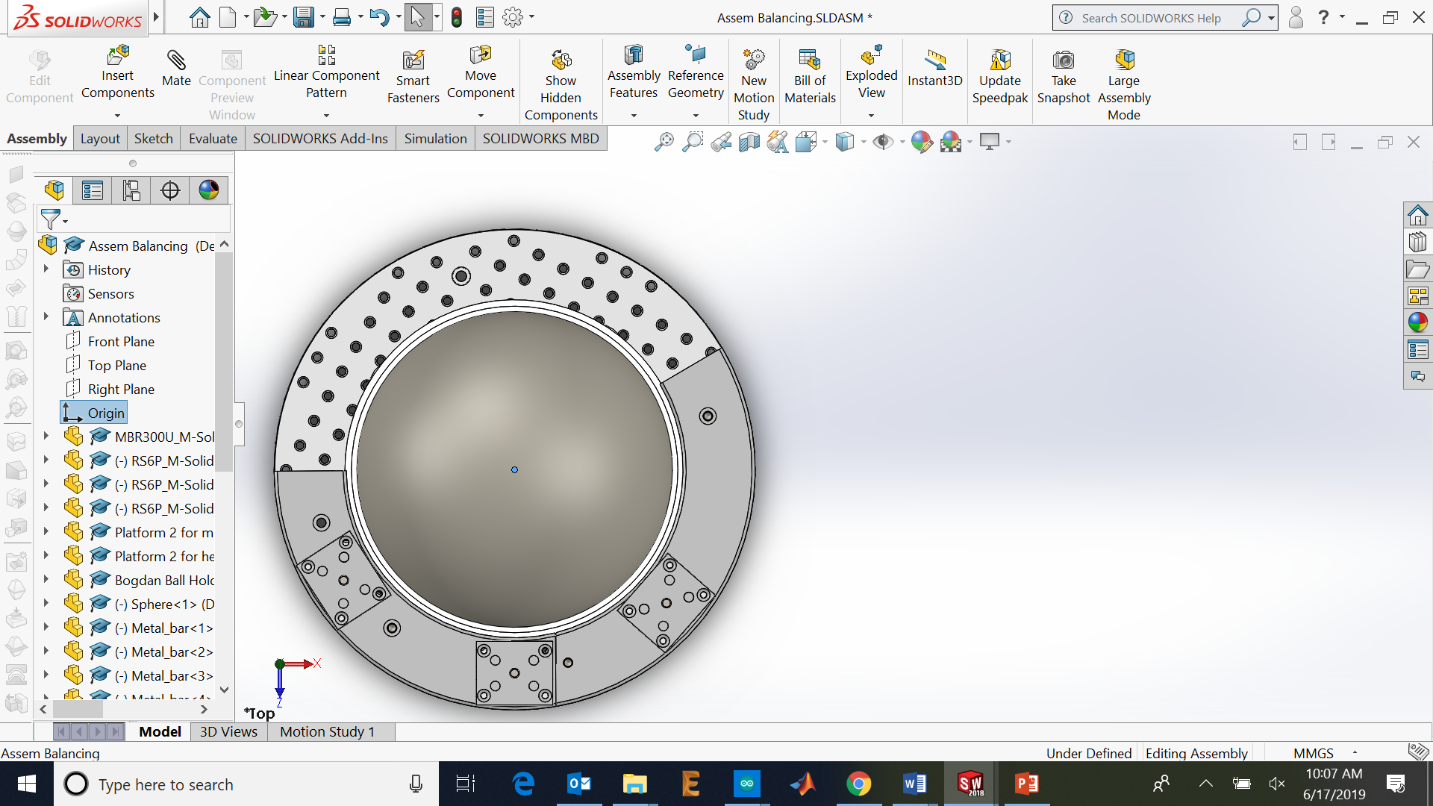
Figure 1: Coordinates system origin (blue dot) and axis.
Then the location of the center of gravity of each component of the assembly has been determined by selecting the part/parts on the left menu and clicking on Evaluate > Mass properties. Each of these coordinates thas been writen on the script variables. Extra components can be included on the script by initializing the variables (m, xcoor, zcoor) and adding another element on the vectors. The next pictures are examples of the coordinates and the mass of each group of elements selected as a procedure.
$$m_{breadboard}=2190 g$$
$${(x,z)}_{CGbreadboard}=(0,0) mm$$
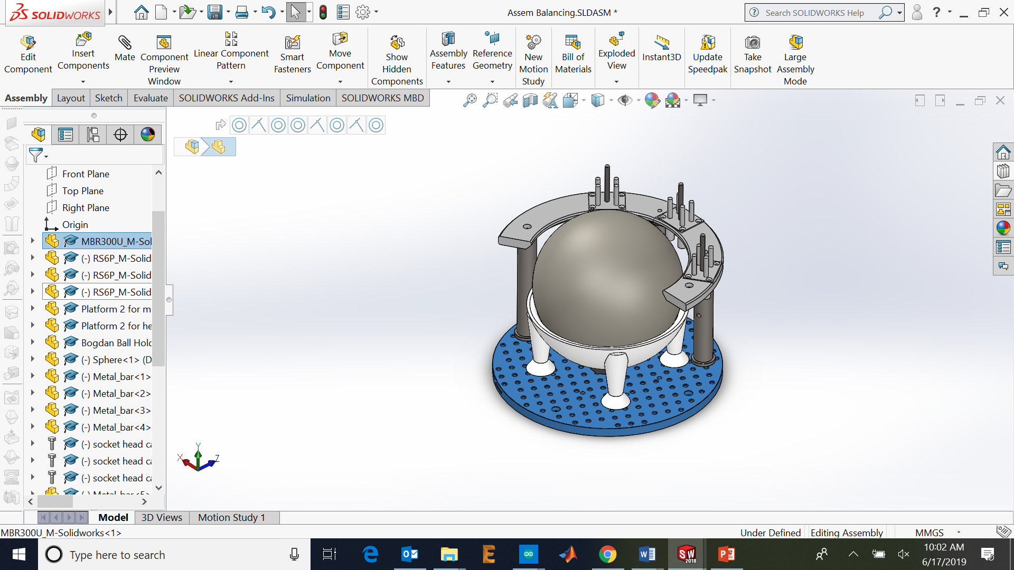

$$m_{sphere}=229 g$$
$${(x,z)}_{CGsphere}=(0,0) mm$$
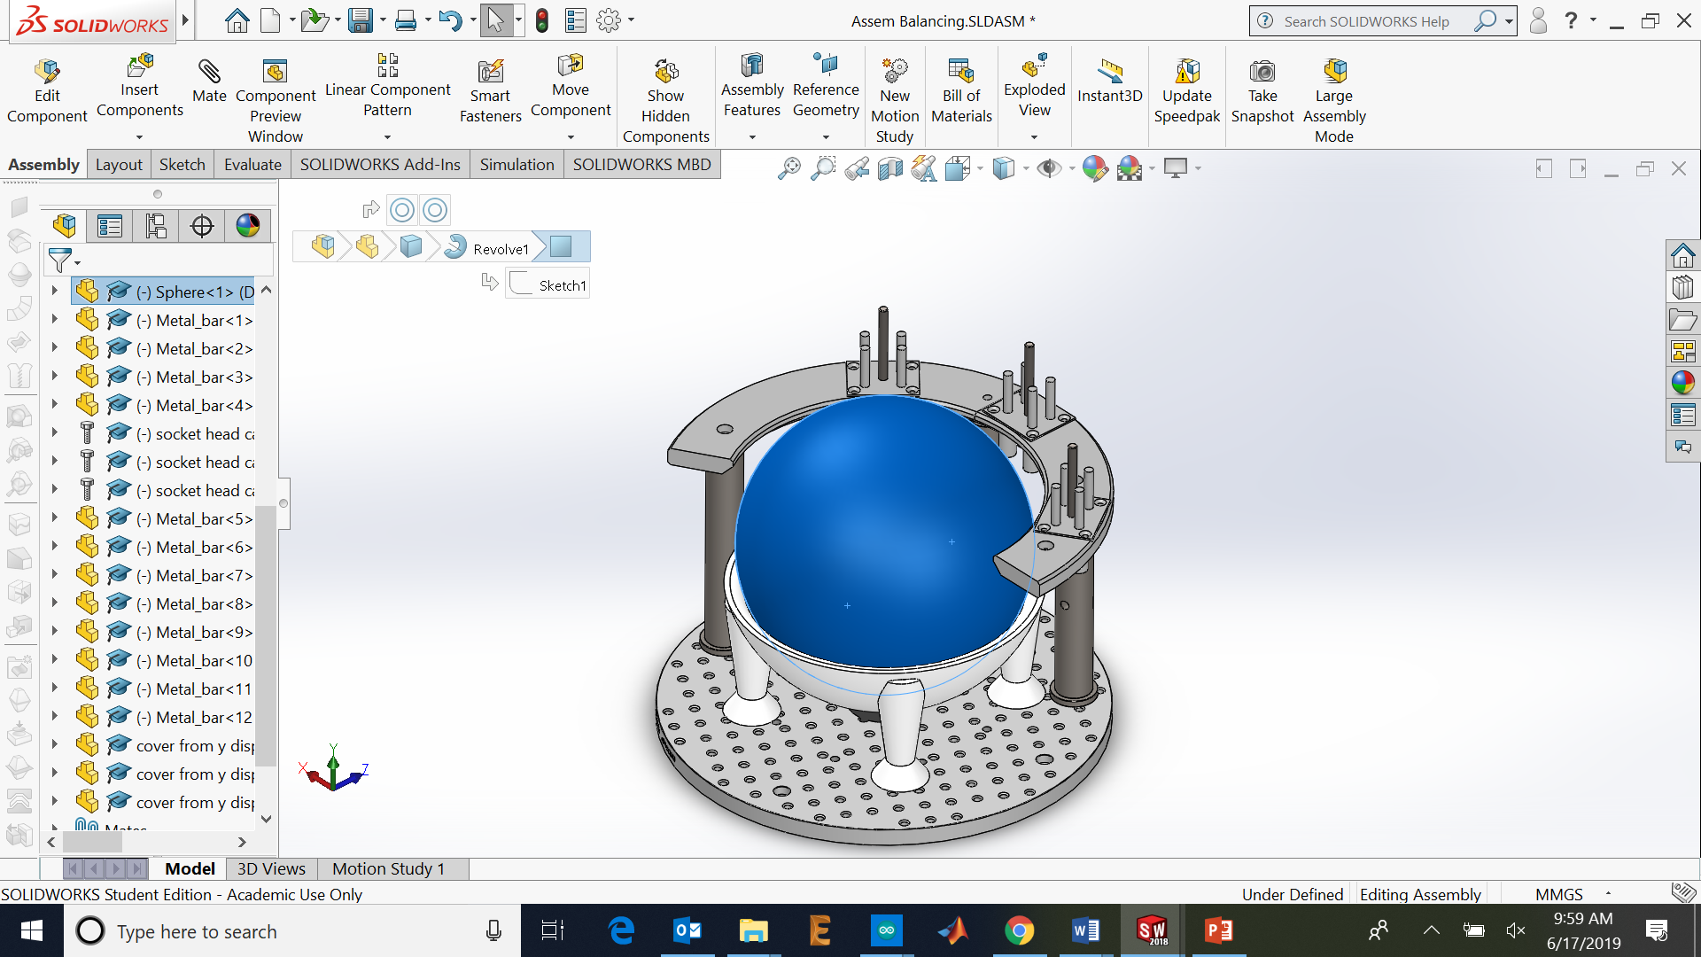
$$m_{holder}=644 g$$
$${(x,z)}_{CGholder}=(0,0) mm$$
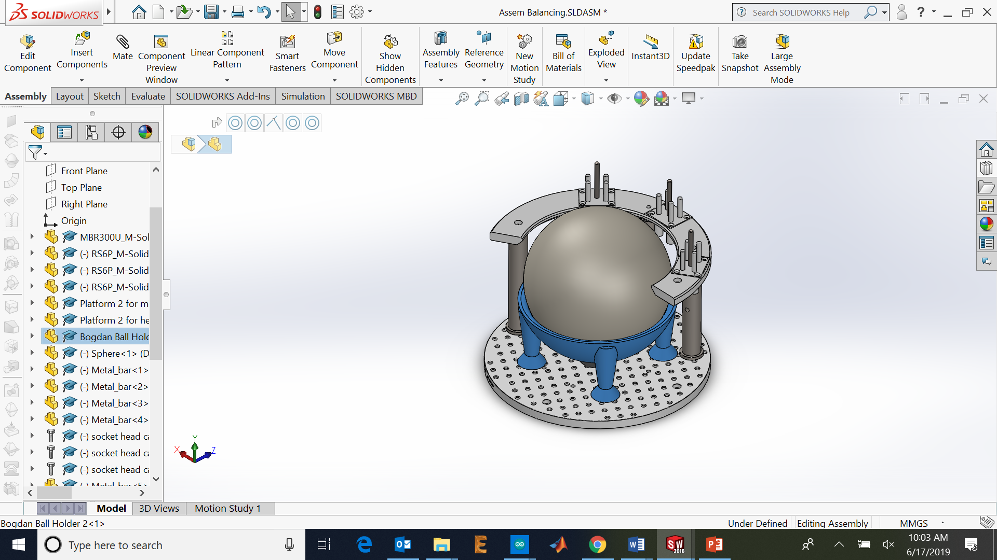
$$m_{circular platform}=2380 g$$
$${(x,z)}_{CGcircular platform}=(22.87 , 64.07) mm$$

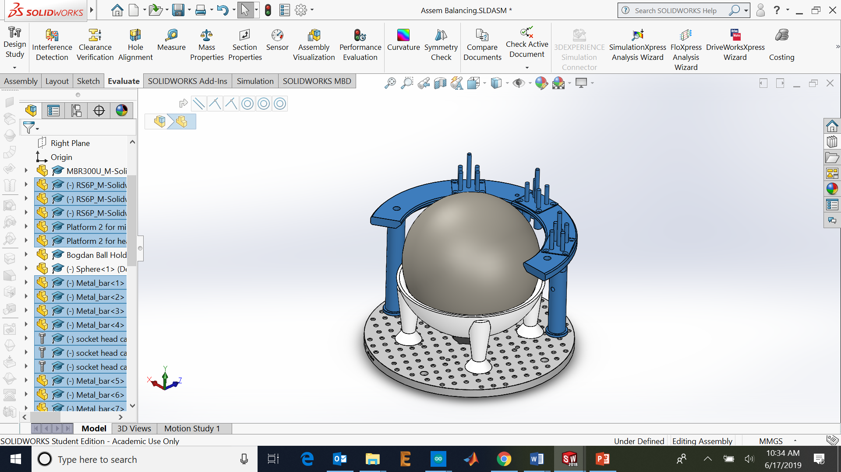
$$m_{IRholderfront}=336 g$$
$${(x,z)}_{CGIRholderfront}=(5.35 , -140.83) mm$$
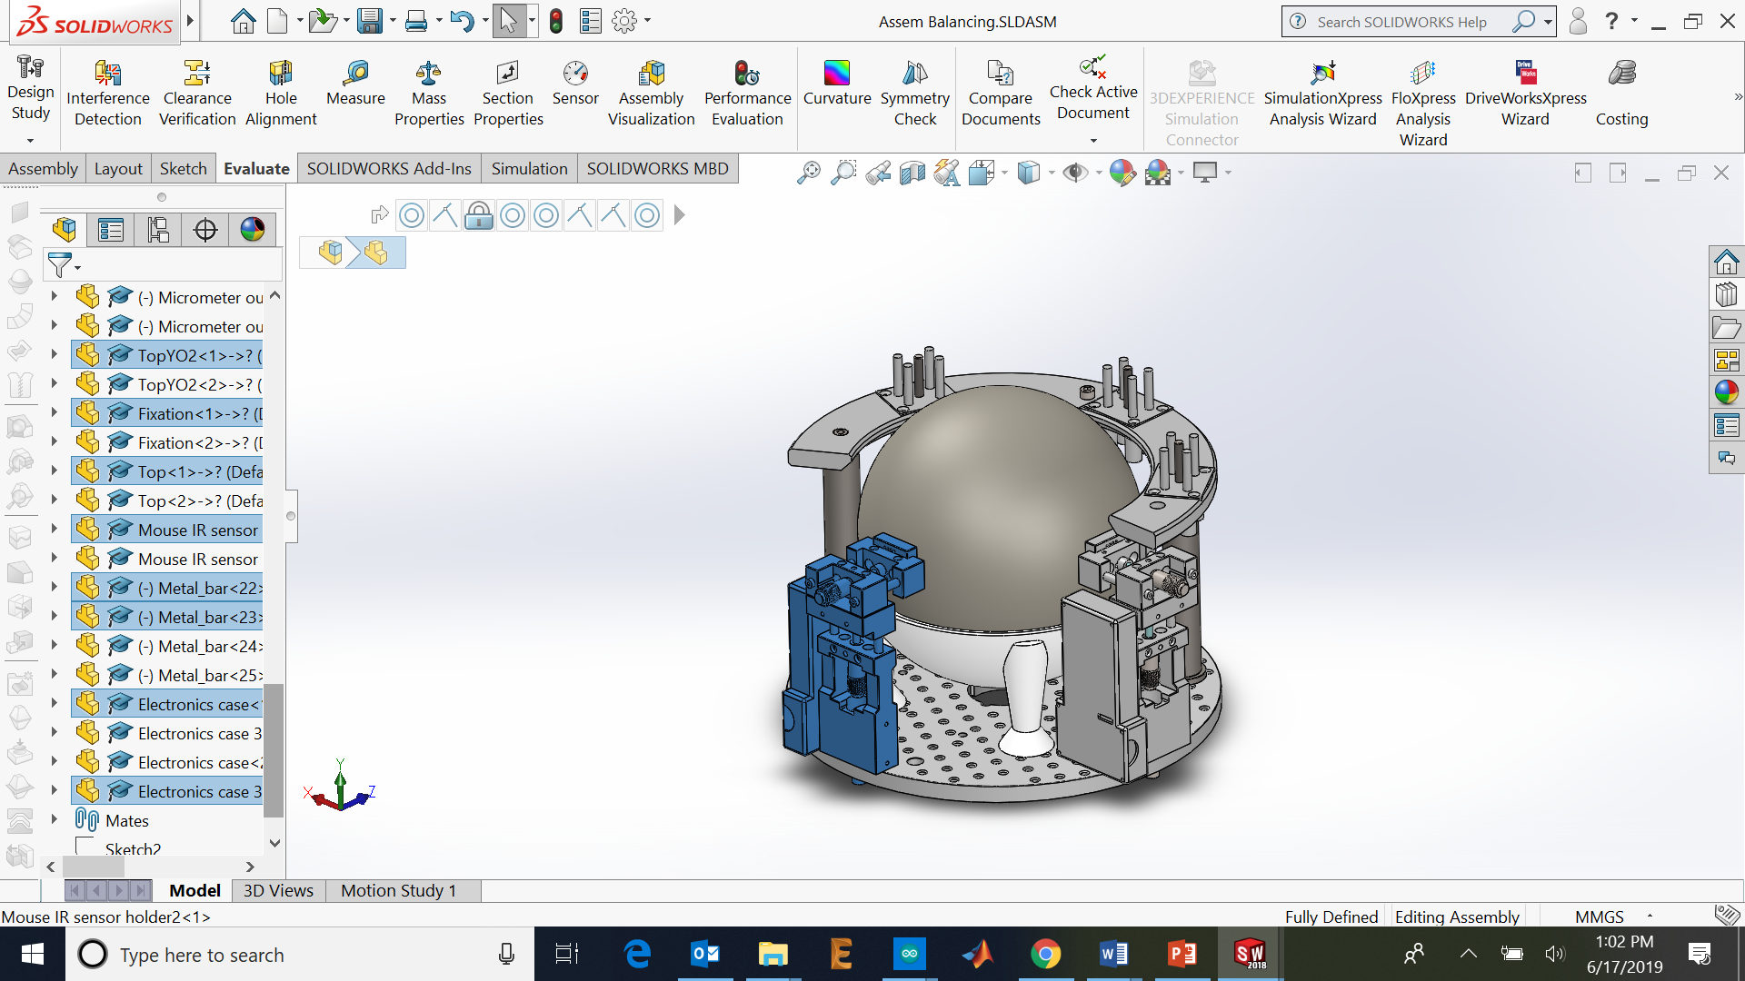
$$m_{IRholderside}=336 g$$
$${(x,z)}_{CGIRholderside}=(-140.83,-5.35) mm$$
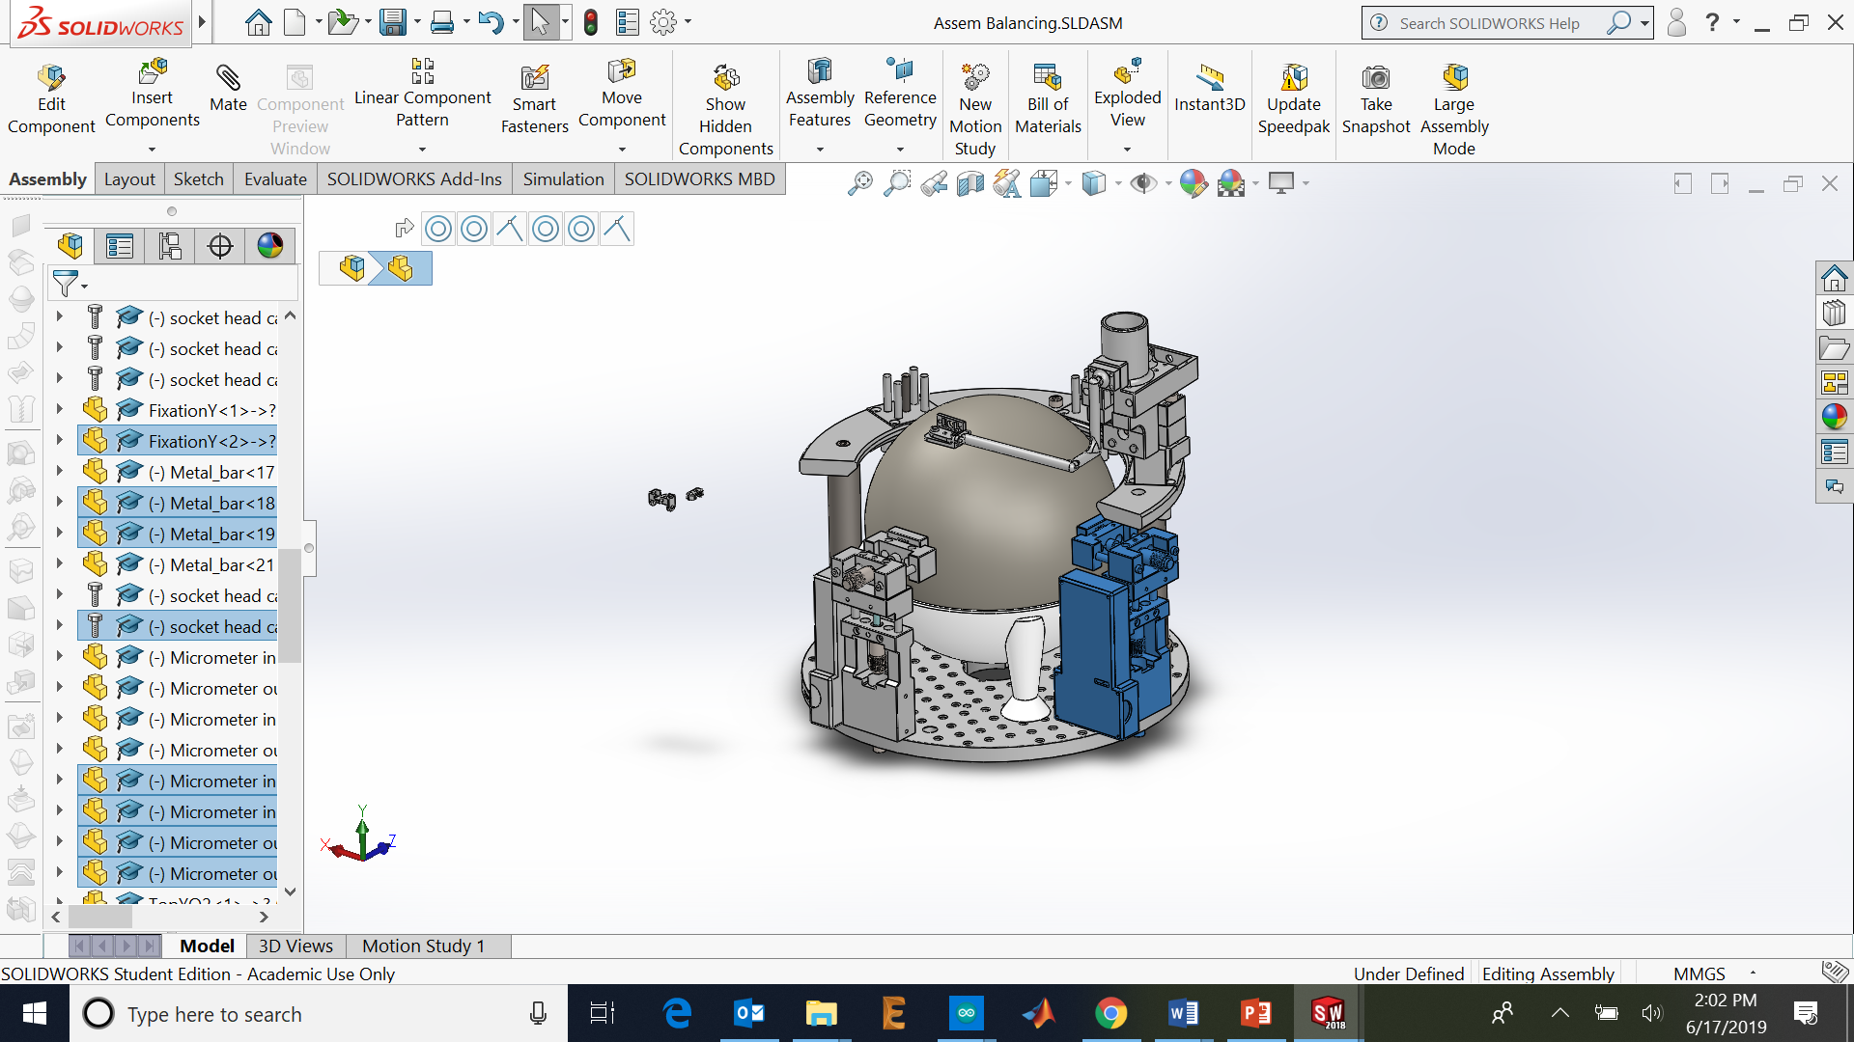
$$m_{lickport}=334 g$$
$${(x,z)}_{CGlickport}=(-104.83 , 47.53) mm$$
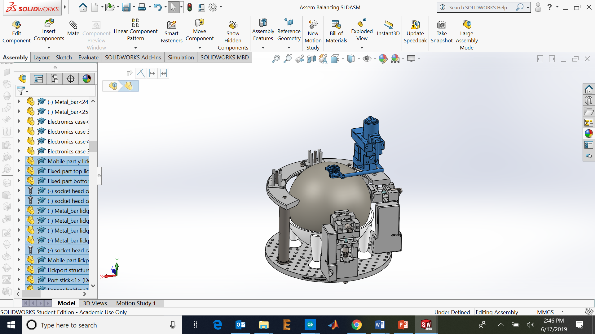

$$m_{headpost}=523 g$$
$${(x,z)}_{CGheadpost}=(0.47 , 111.03) mm$$
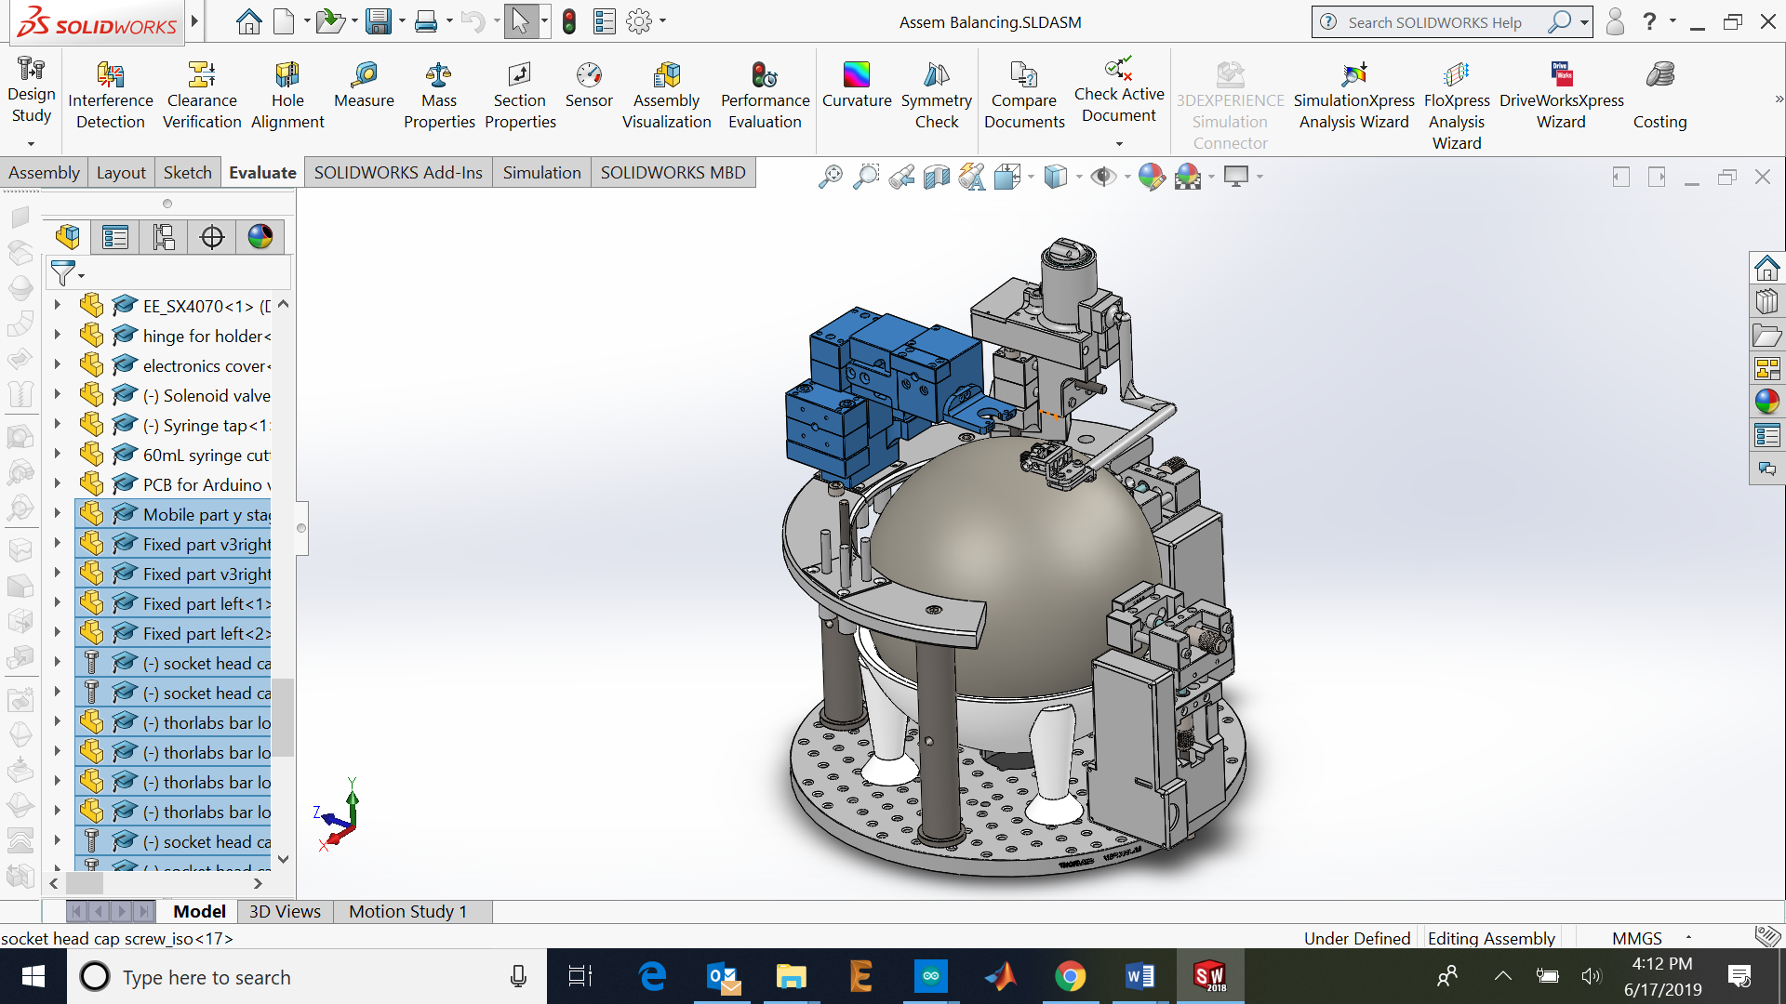
$$m_{camera}=347 g$$
$${(x,z)}_{CGcamera}=(123.63 , 32.30) mm$$
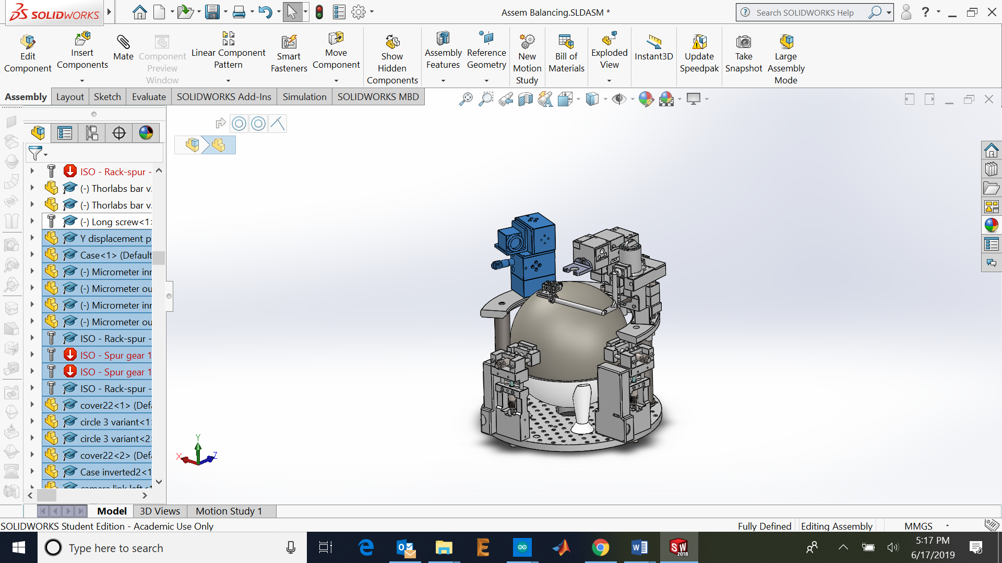
$$m_{postextra1}=599 g$$
$${(x,z)}_{CGpostextra1}=(91.81 , -90.19) mm$$
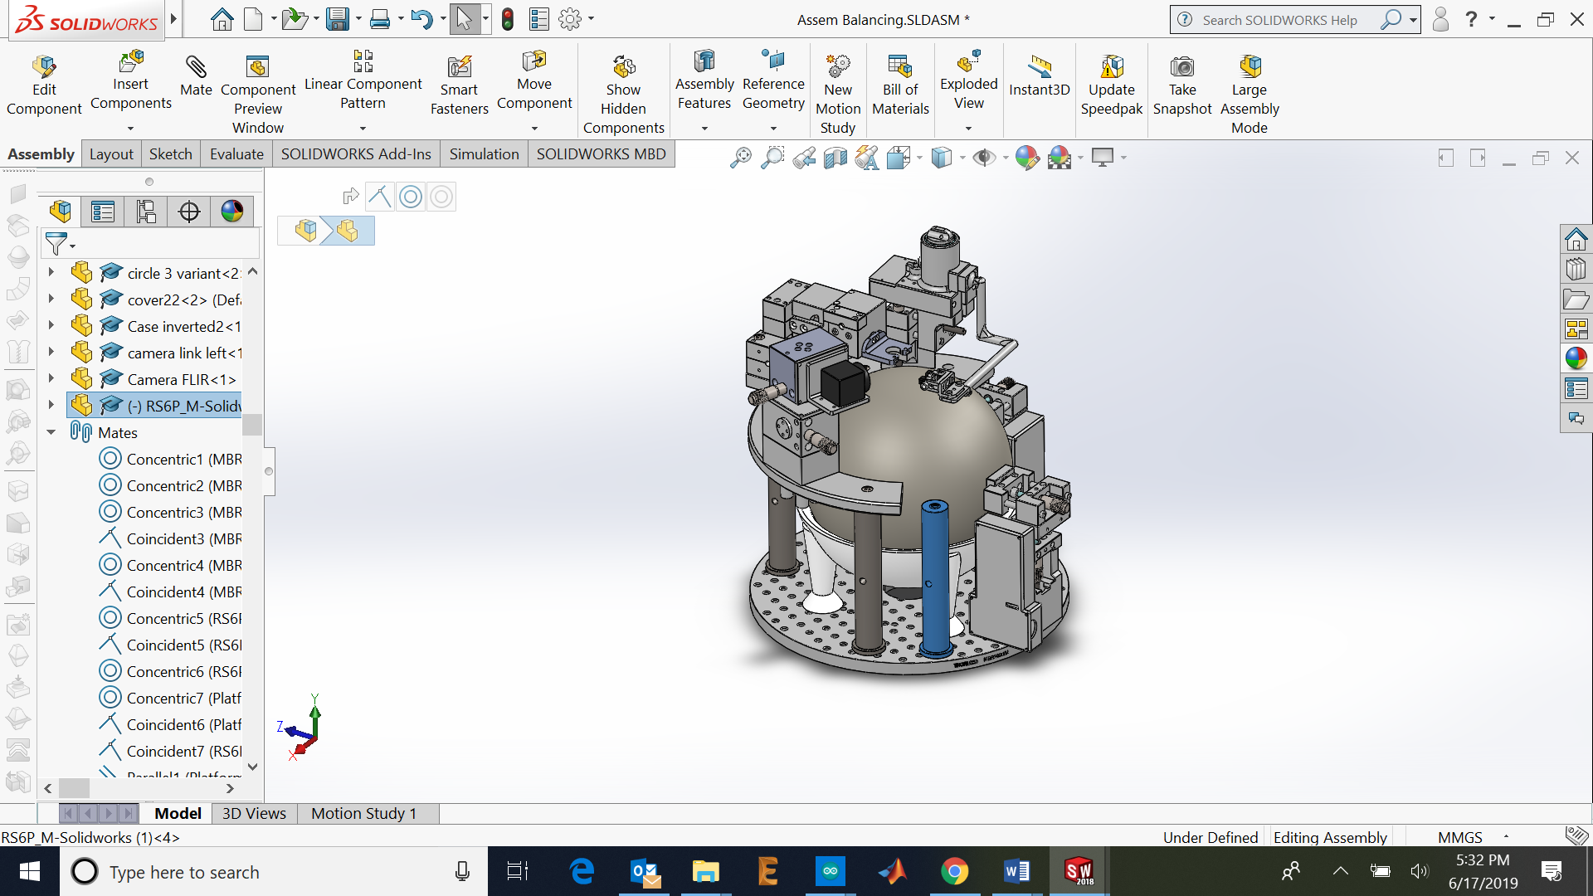
$$m_{postextra2}=599 g$$
$${(x,z)}_{CGpostextra2}=(-98.91,-76.43) mm$$
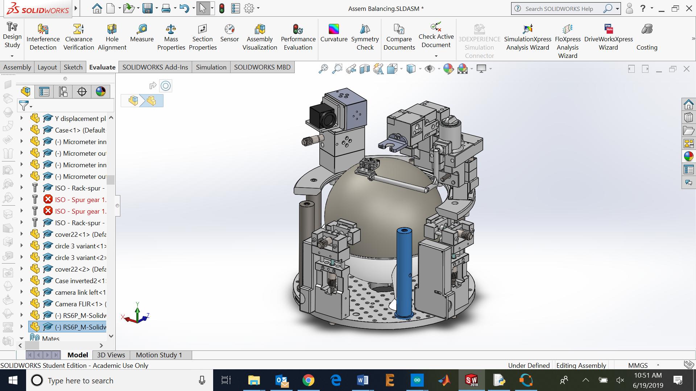
$$m_{postextra3}=599 g$$
$${(x,z)}_{CGpostextra3}=(x_{postextra3},z_{postextra3}) mm$$
Equations:
$$Xg= \frac{\sum{m_{i}x_{i}}}{M}$$
$$Zg= \frac{\sum{m_{i}z_{i}}}{M}$$
Impose the CG ($Xg$ ,$Zg$) in the (0,0):
$$\frac{\sum{m_{i}x_{i}}}{M}=0$$
$$\frac{\sum{m_{i}z_{i}}}{M}=0$$
Developed for the x coordinate:
$$\frac{m_{breadboard}*x_{breadboard}+m_{sphere}*x_{sphere}+m_{holder}*x_{holder}+m_{circular platform}*x_{circular platform}+}{M}…$$
$$… \frac{m_{IRholderfront}*x_{IRholderfront}+m_{IRholderside}*x_{IRholderside}+m_{lickport}*x_{lickport}+m_{headpost}*x_{headpost}}{M}…$$
$$…\frac{m_{camera}*x_{camera}+m_{postextra1}*x_{postextra1}+m_{postextra2}*x_{postextra2}+m_{postextra3}*x_{postextra3}}{M}=0$$

Developed for the z coordinate:
$$\frac{m_{breadboard}*z_{breadboard}+m_{sphere}*z_{sphere}+m_{holder}*z_{holder}+m_{circular platform}*z_{circular platform}+}{M}…$$
$$… \frac{m_{IRholderfront}*z_{IRholderfront}+m_{IRholderside}*z_{IRholderside}+m_{lickport}*z_{lickport}+m_{headpost}*z_{headpost}}{M}…$$
$$…\frac{m_{camera}*z_{camera}+m_{postextra1}*z_{postextra1}+m_{postextra2}*z_{postextra2}+m_{postextra3}*z_{postextra3}}{M}=0$$

The unknowns are the $x_{postextra2}$ and $z_{postextra2}$:

$$\frac{\sum{m_{i}x_{i}}+m_{postextra3}*x_{postextra3}}{M}=0$$

$$\frac{\sum{m_{i}z_{i}}+m_{postextra3}*z_{postextra3}}{M}=0$$

$$x_{postextra3}= \frac{-\sum{m_{i}x_{i}}}{m_{postextra3}}$$

$$z_{postextra3}= \frac{-\sum{m_{i}z_{i}}}{m_{postextra3}}$$
The strategy is to add two or three posts as constraints to get the position of the last post needed, then to check if this position is not coincident with any existing hole or is outside of the breadboard. The Matlab script automates the calculation of this result in the analytical way. Figure 2 is a display of the position of the 3rd post on the platform. The result is also stored in the variables: Xgpostextra3 and Zgpostextra3.
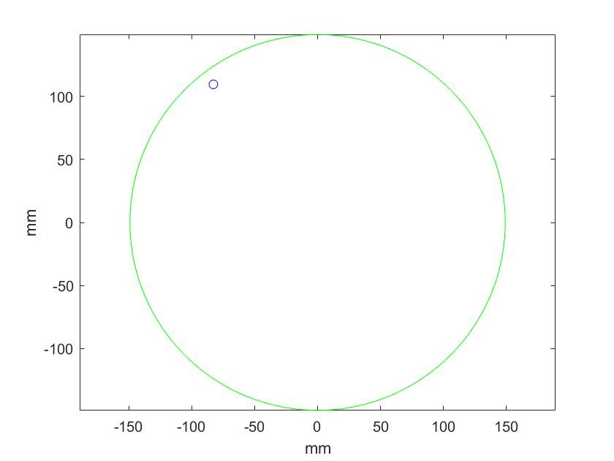
Figure 2: Placement of the 3rd post displayed on the Matlab script.
With this system, calculating the position of the 3rd post with the script, adding an additional hole and placing the 3rd post on this additional hole, the precision achieved can be checked by clicking on Evaluate > Mass properties of the whole assembly. The placement of the post in the new hole places the CG in the coordinates x = -0.01 z = 0.02 mm. This is the best result that has been achieved.
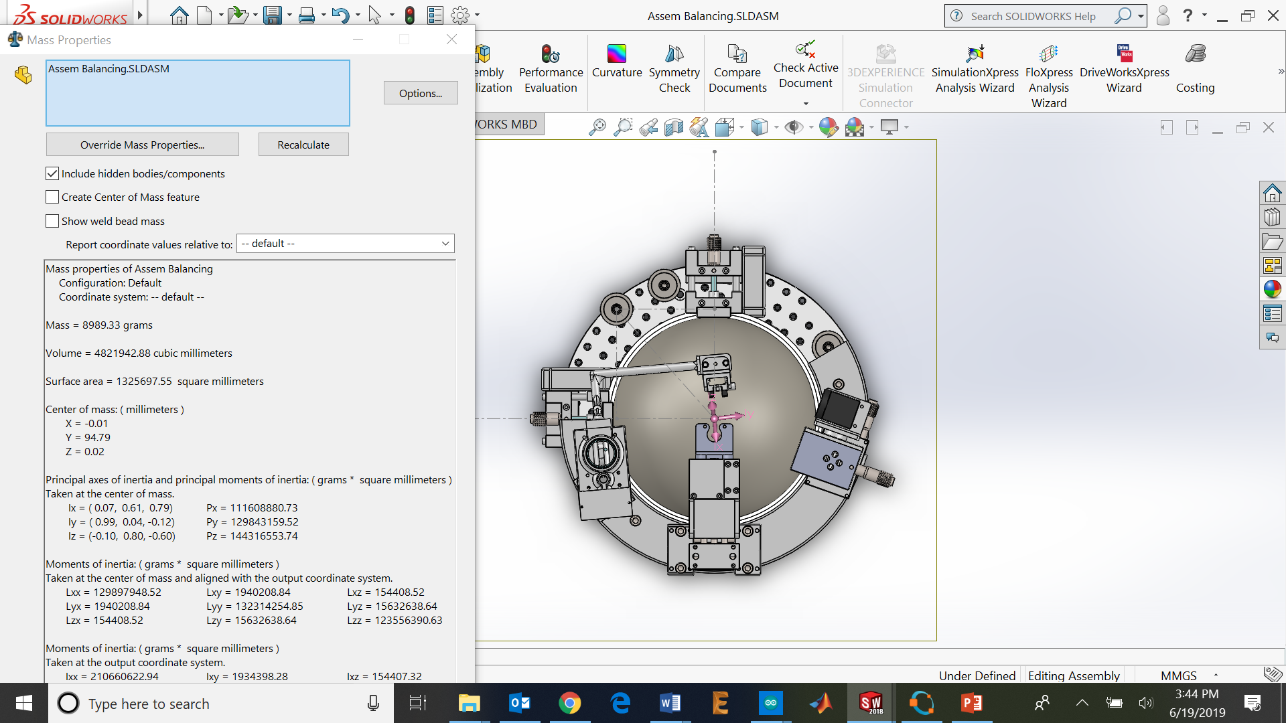
Figure 3: Method placing the post to an extra hole.
That method can be used also to find an existing hole without making a new one. In the figure below the CG is displaced x = 0.46 mm and z = -0.21 mm from the Coordinates origin.
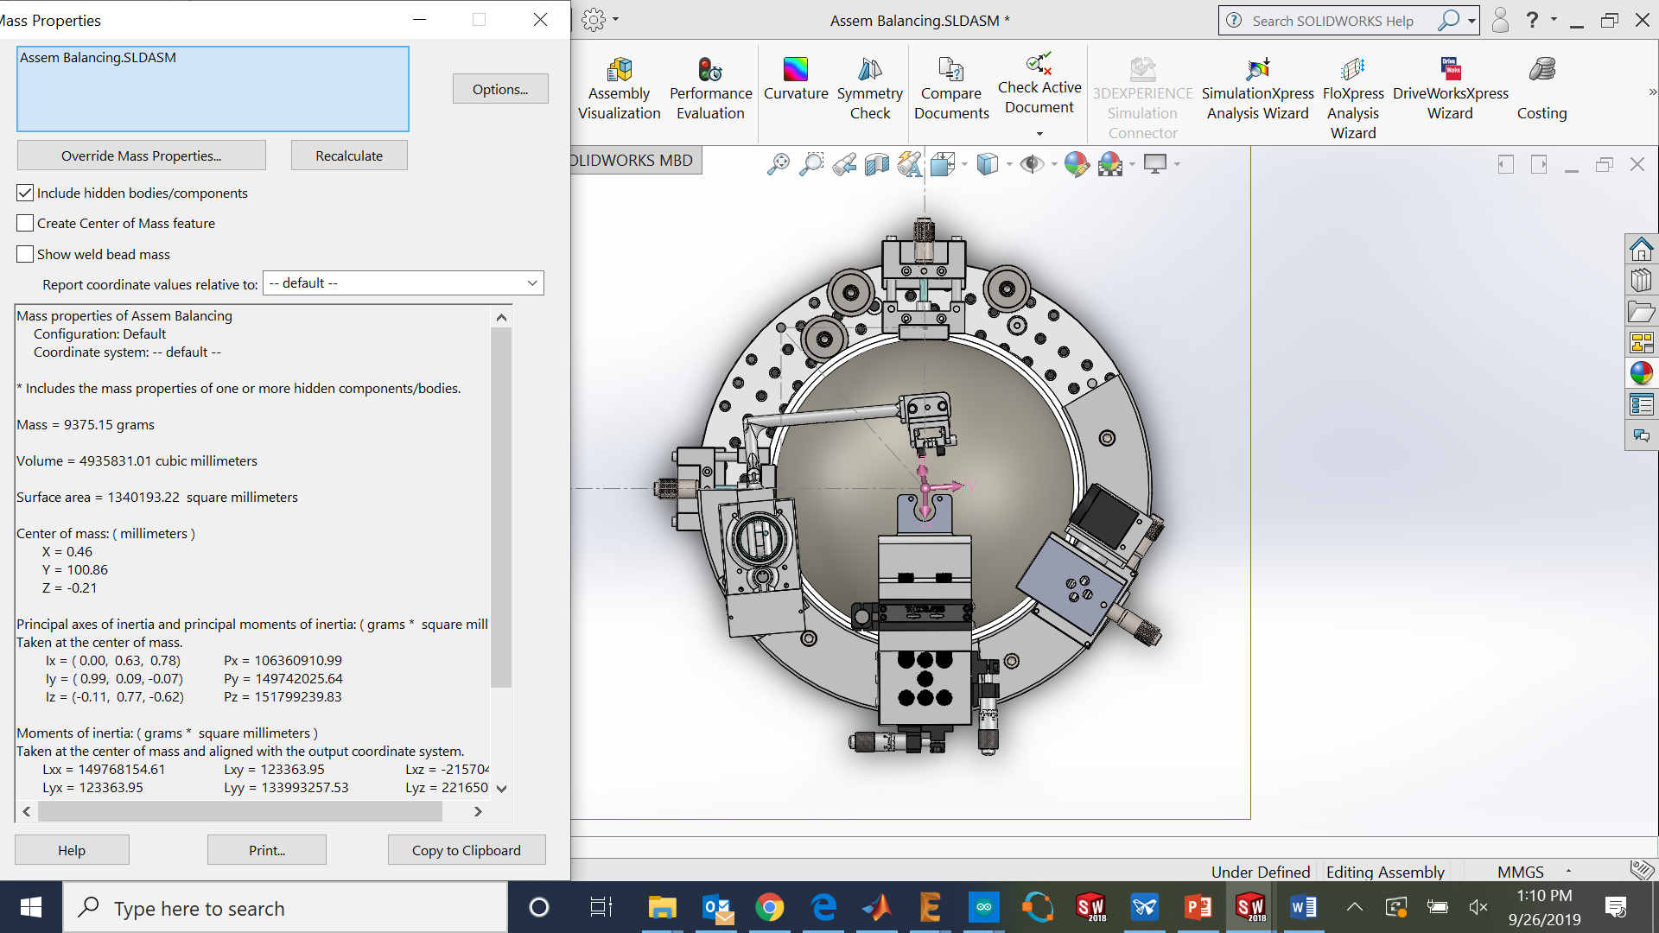
Figure 4: Method placing the post in an existing hole (with a small extra post on the right side, this is the current location used for the last motor tuning).

Figure 5: Current location used for the last motor tuning using existing holes.

